WEEK-7
REACTJS-HOL

9.ReactJs-HOL
MY CODE:
App.js
import React from 'react';
import './App.css';
import ListofPlayers from './components/ListofPlayers';
import IndianPlayers from './components/IndianPlayers';
function App() {
const flag = true;
return (
<div className="App">
<h1>Cricket App</h1>
{flag ? <ListofPlayers /> : <IndianPlayers />}
</div>
);
}
export default App;

ListofPlayers.js

import React from 'react';

const ListofPlayers = () => {

const players = [

{ name: 'Virat', score: 80 },

{ name: 'Rohit', score: 95 },

{ name: 'Rahul', score: 60 },

{ name: 'Pant', score: 40 },

{ name: 'Jadeja', score: 70 },

{ name: 'Hardik', score: 85 },

{ name: 'Ashwin', score: 65 },

{ name: 'Bumrah', score: 90 },

{ name: 'Shami', score: 55 },

{ name: 'Surya', score: 76 },

{ name: 'Gill', score: 68 }

];

const highScorers = players.map(player => (

<li key={player.name}>{player.name} - {player.score}</li>

));

const below70 = players.filter(player => player.score < 70).map(p => (

<li key={p.name}>{p.name} - {p.score}</li>

));

return (

<div>

<h2>All Players</h2>

<ul>{highScorers}</ul>

<h3>Players with Score Below 70</h3>

<ul>{below70}</ul>

</div>

);

};

export default ListofPlayers;

IndianPlayers.js

import React from 'react';

const IndianPlayers = () => {

const T20players = ['Kohli', 'Rohit', 'Pant'];

const RanjiTrophy = ['Jaiswal', 'Sarfaraz', 'Iyer'];

const allPlayers = [...T20players, ...RanjiTrophy];

const [odd1, even1, odd2, even2, odd3, even3] = allPlayers;

return (

<div>

<h2>Merged Players</h2>

<ul>

{allPlayers.map((player, index) => (

<li key={index}>{player}</li>

))}

</ul>

<h3>Odd Team</h3>

<ul>

<li>{odd1}</li>

<li>{odd2}</li>

<li>{odd3}</li>

</ul>

<h3>Even Team</h3>

<ul>

<li>{even1}</li>

<li>{even2}</li>

<li>{even3}</li>

</ul>

</div>

);

};

export default IndianPlayers;

OUTPUT:
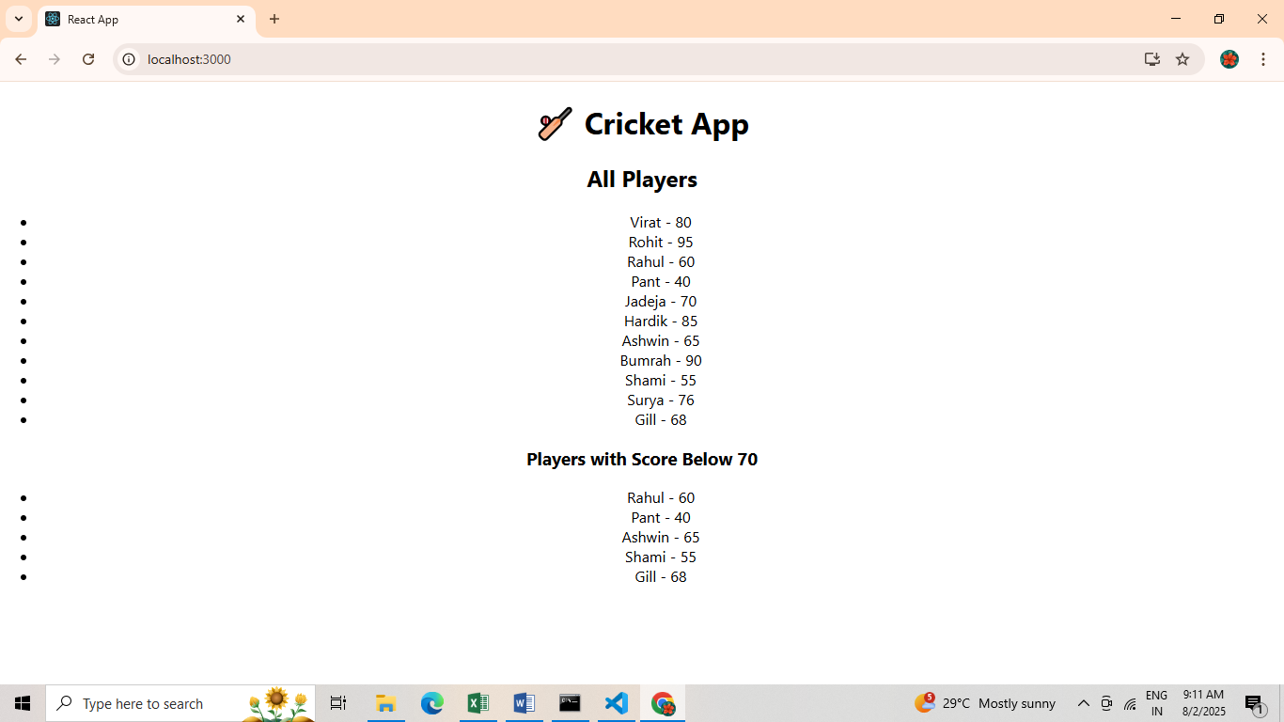

10.ReactJs-HOL
MY CODE:
App.js
import React from 'react';
const offices = [
{
name: "Alpha Workspace",
rent: 55000,
address: "123 Main St, Chennai",
image: "https://via.placeholder.com/200x120"
},
{
name: "Beta Hub",
rent: 70000,
address: "456 Business Rd, Bangalore",
image: "https://via.placeholder.com/200x120"
}
];
function App() {
return (
<div style={{ padding: '20px' }}>
<h1>Office Space Rental App</h1>
{offices.map((office, index) => (
<div key={index} style={{
border: '1px solid gray',
borderRadius: '8px',
padding: '15px',
marginBottom: '15px'
}}>
<img src={office.image} alt={office.name} />
<h2>{office.name}</h2>
<p style={{ color: office.rent < 60000 ? 'red' : 'green' }}>
Rent: ₹{office.rent}
</p>
<p>Address: {office.address}</p>
</div>
))}
</div>
);
}
export default App;

OUTPUT:
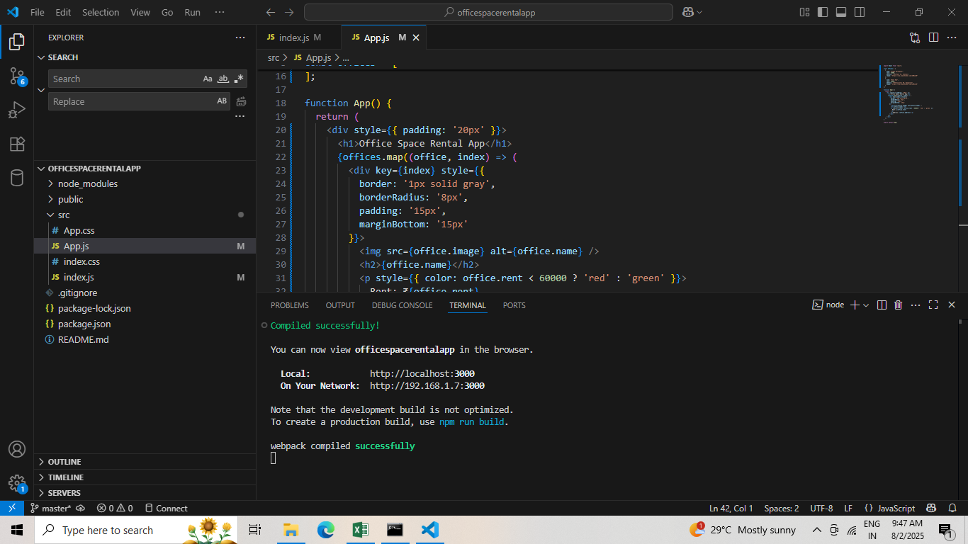
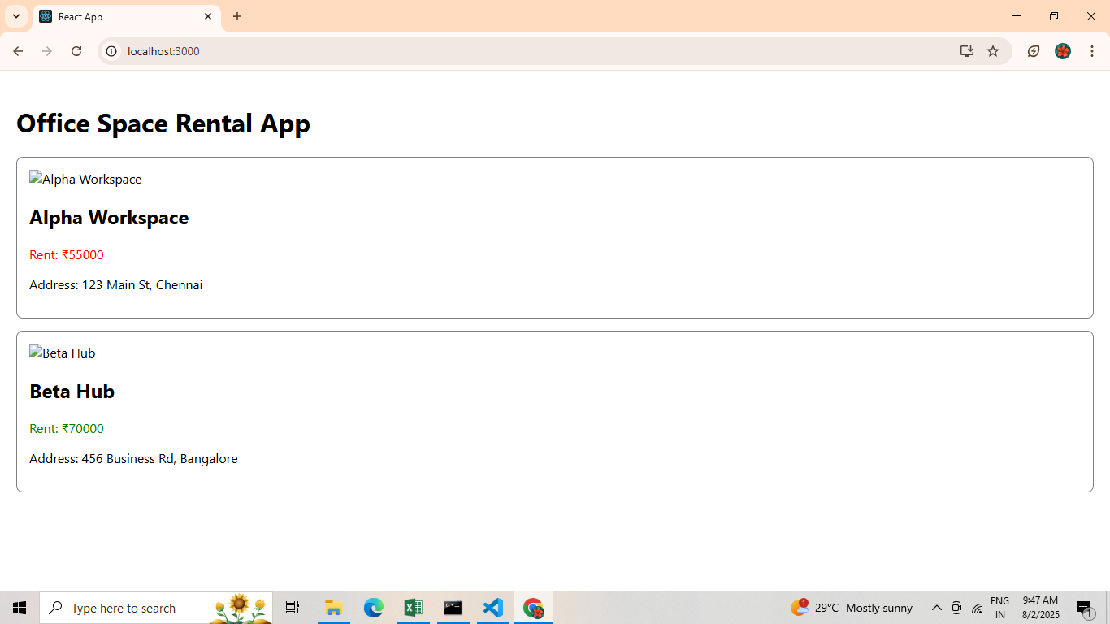

11.ReactJs-HOL
MY CODE:
App.js
import React, { useState } from 'react';
import CurrencyConvertor from './CurrencyConvertor';
function App() {
const [count, setCount] = useState(0);
const handleIncrement = () => {
increment();
sayHello();
};
const increment = () => {
setCount(prev => prev + 1);
};
const decrement = () => {
setCount(prev => prev - 1);
};
const sayHello = () => {
console.log("Hello! This is a static message.");
};
const sayWelcome = (message) => {
alert(`Message: ${message}`);
};
const handleSyntheticEvent = (event) => {
console.log("I was clicked");
console.log("Event type:", event.type);
};
return (
<div style={{ padding: '20px' }}>
<h1>React Event Handling Example</h1>
<h2>Counter: {count}</h2>
<button onClick={handleIncrement}>Increment</button>
<button onClick={decrement}>Decrement</button>
<hr />
<button onClick={() => sayWelcome("Welcome")}>Say Welcome</button>
<hr />
<button onClick={handleSyntheticEvent}>Synthetic Event (OnPress)</button>
<hr />
<CurrencyConvertor />
</div>
);
}
export default App;

CurrencyConvertor.js
import React, { useState } from 'react';
function CurrencyConvertor() {
const [rupees, setRupees] = useState('');
const [euro, setEuro] = useState('');
const handleSubmit = () => {
const euroValue = parseFloat(rupees) / 90;
setEuro(euroValue.toFixed(2));
};
return (
<div>
<h2>Currency Convertor</h2>
<input
type="number"
value={rupees}
onChange={(e) => setRupees(e.target.value)}
placeholder="Enter amount in INR"
/>
<button onClick={handleSubmit}>Convert to Euro</button>
{euro && <p>Converted Value: €{euro}</p>}
</div>
);
}
export default CurrencyConvertor;

OUTPUT:
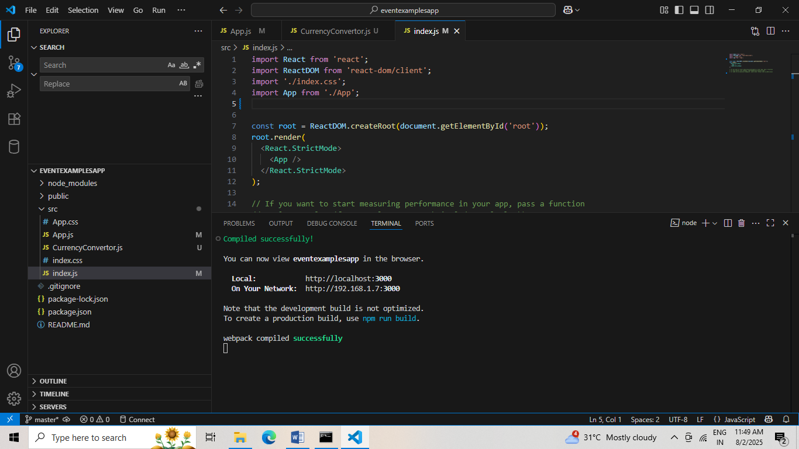

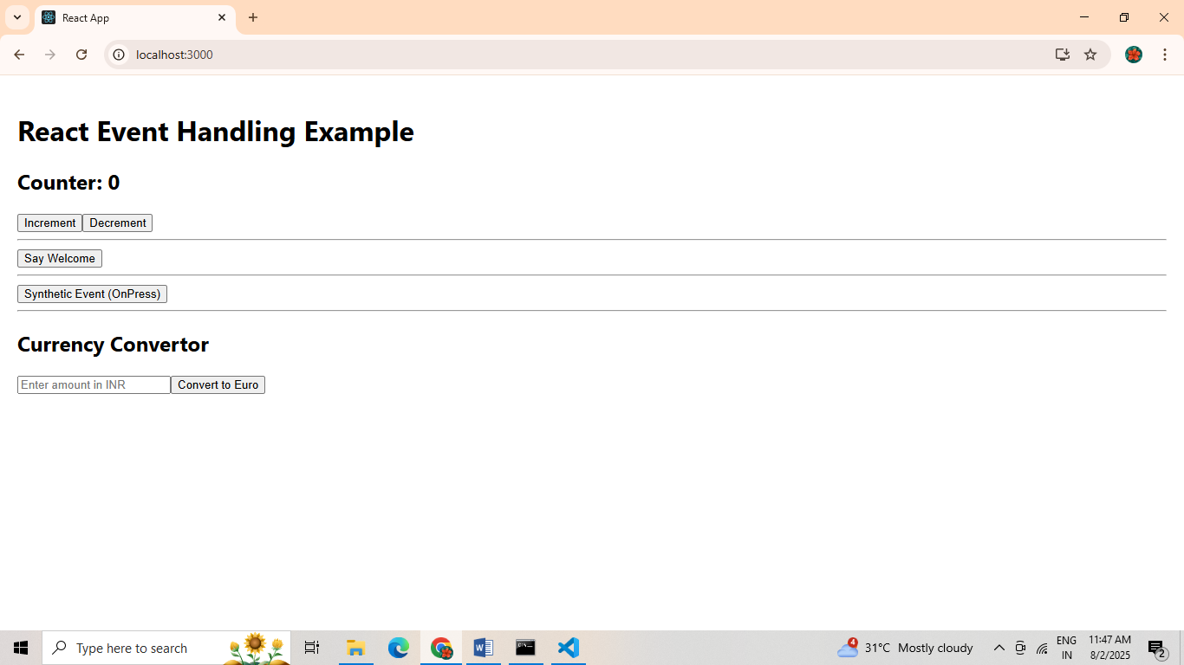

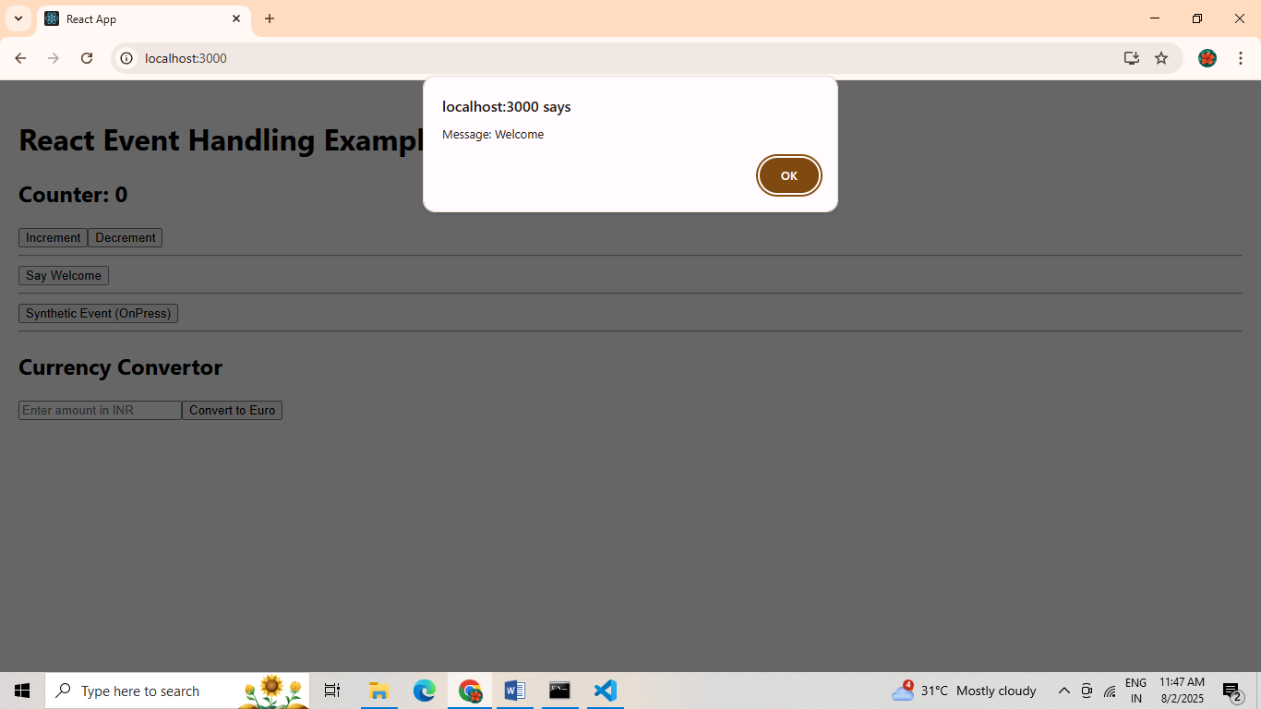

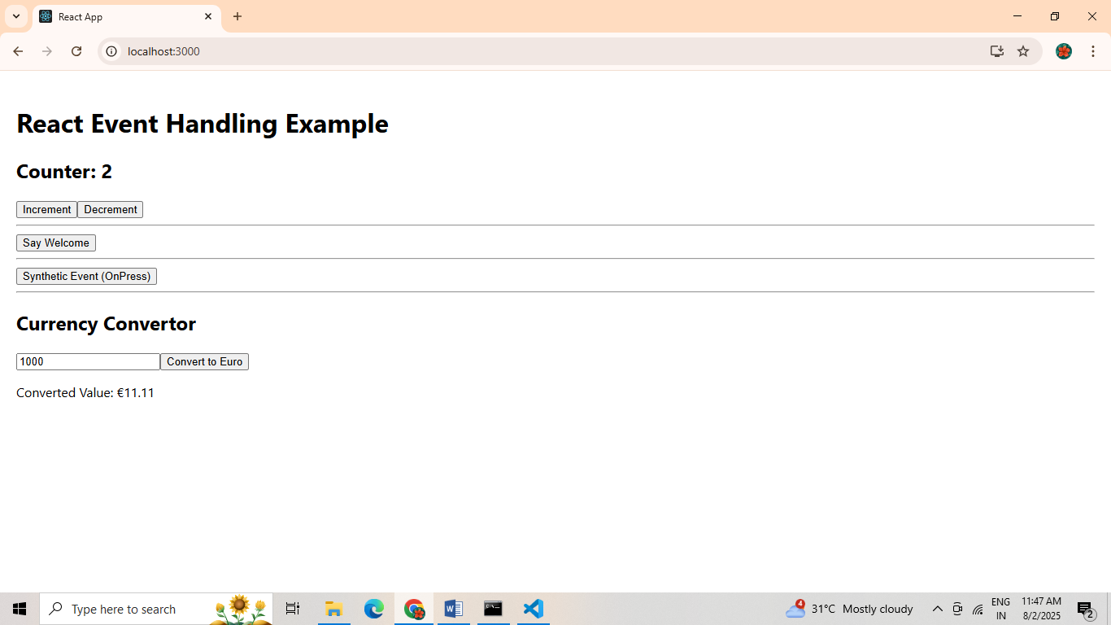

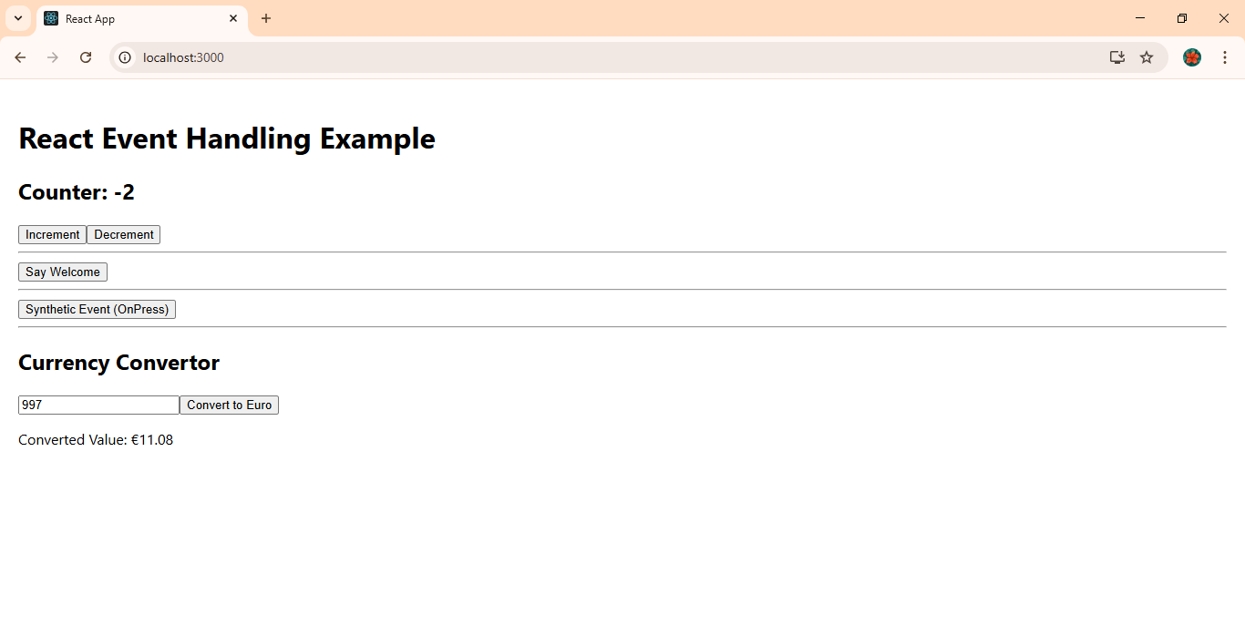

12.ReactJs-HOL
MY CODE:
App.js
import React, { useState } from 'react';
function App() {
const [isLoggedIn, setIsLoggedIn] = useState(false);
const flightDetails = [
{ flight: 'AI-202', destination: 'Chennai', price: 3500 },
{ flight: '6E-101', destination: 'Delhi', price: 4200 },
];
const handleLogin = () => {
setIsLoggedIn(true);
};
const handleLogout = () => {
setIsLoggedIn(false);
};
let content;
if (isLoggedIn) {
content = (
<div>
<h2>Welcome, User!</h2>
<p>You can now book tickets.</p>
<button onClick={handleLogout}>Logout</button>
<hr />
<h3>Available Flights:</h3>
{flightDetails.map((flight, index) => (
<div key={index} style={{ marginBottom: "10px" }}>
<p>Flight: {flight.flight}</p>
<p>Destination: {flight.destination}</p>
<p>Price: ₹{flight.price}</p>
<button>Book Ticket</button>
<hr />
</div>
))}
</div>
);
} else {
content = (
<div>
<h2>Hello, Guest!</h2>
<p>Please login to book tickets.</p>
<button onClick={handleLogin}>Login</button>
<hr />
<h3>Available Flights:</h3>
{flightDetails.map((flight, index) => (
<div key={index} style={{ marginBottom: "10px" }}>
<p>Flight: {flight.flight}</p>
<p>Destination: {flight.destination}</p>
<p>Price: ₹{flight.price}</p>
<hr />
</div>
))}
</div>
);
}
return (
<div style={{ padding: '20px' }}>
<h1>Ticket Booking App</h1>
{content}
</div>
);
}
export default App;
index.js
import React from 'react';
import ReactDOM from 'react-dom/client';
import './index.css';
import App from './App';
const root = ReactDOM.createRoot(document.getElementById('root'));
root.render(<App />);
OUTPUT:
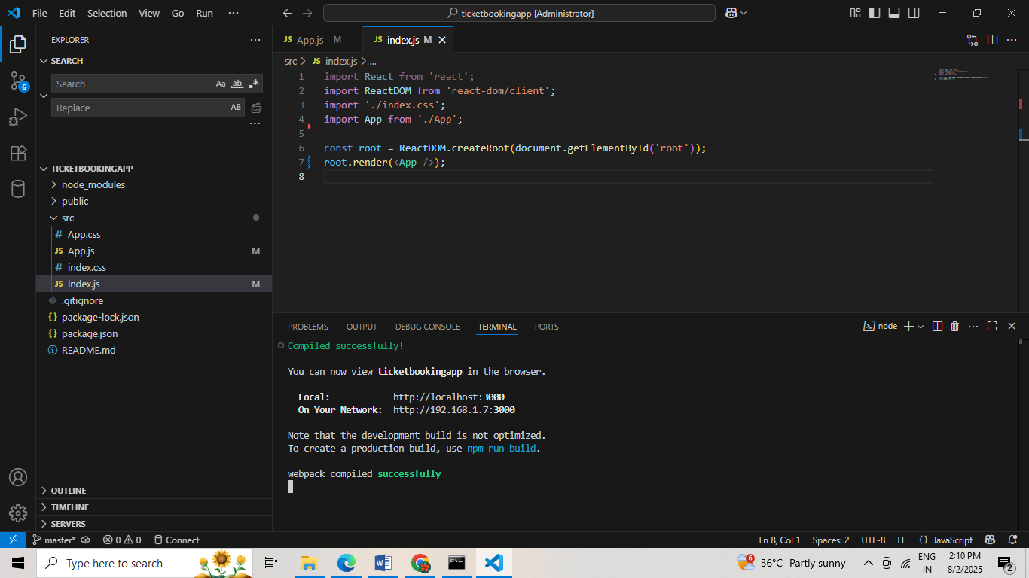

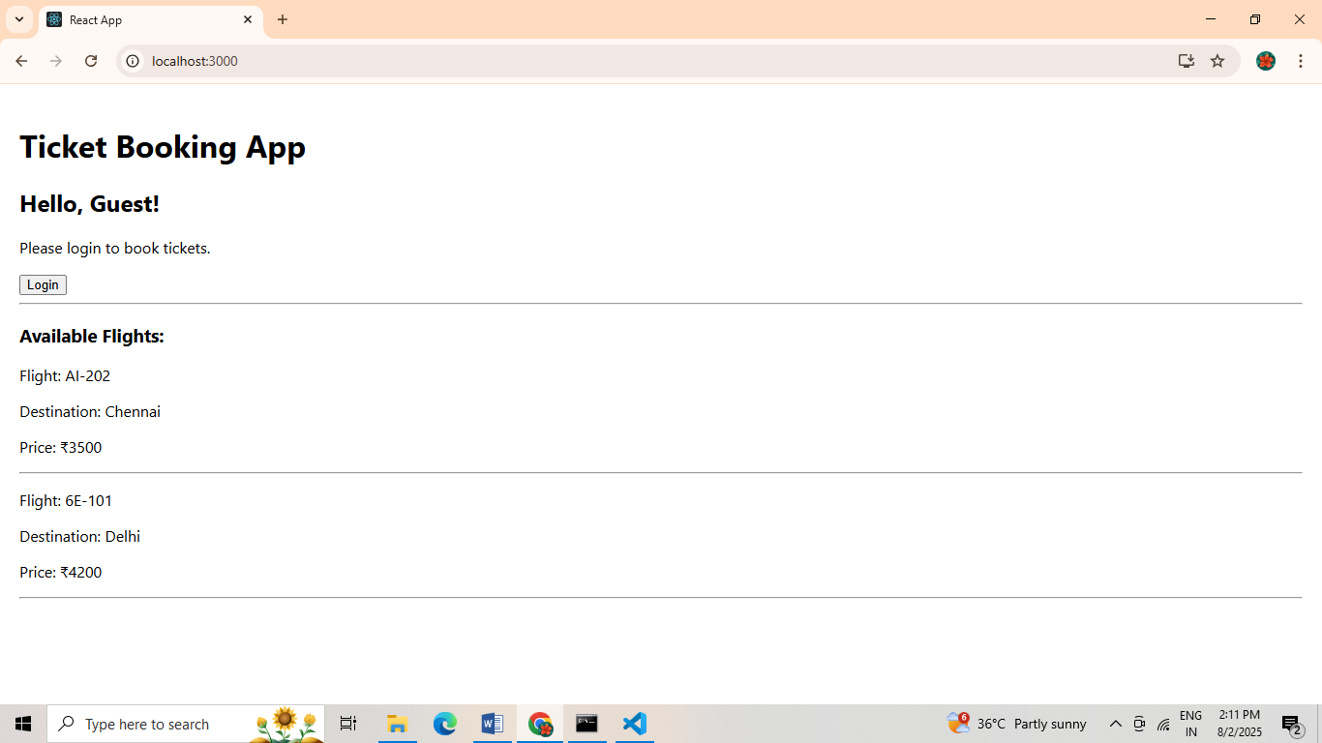

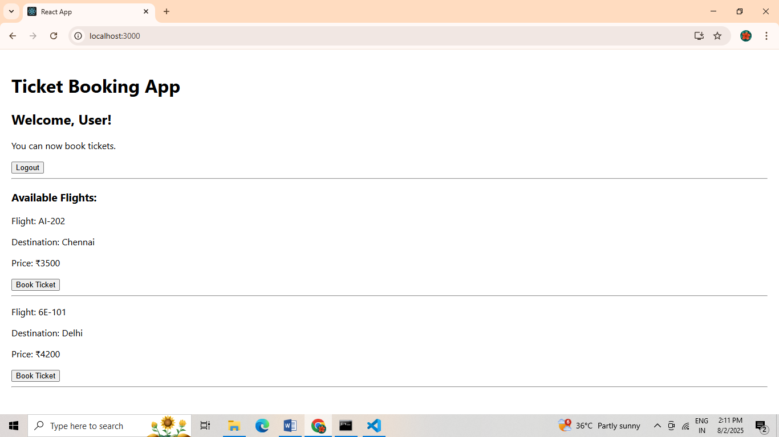

13.ReactJs-HOL
MY CODE:
App.js
import React, { useState } from 'react';
import BookDetails from './BookDetails';
import BlogDetails from './BlogDetails';
import CourseDetails from './CourseDetails';
function App() {
const [view, setView] = useState('book');
const renderComponent = () => {
if (view === 'book') return <BookDetails />;
else if (view === 'blog') return <BlogDetails />;
else if (view === 'course') return <CourseDetails />;
else return <p>Please select a view</p>;
};
return (
<div className="App">
<h1>Blogger App</h1>
<button onClick={() => setView('book')}>Book</button>
<button onClick={() => setView('blog')}>Blog</button>
<button onClick={() => setView('course')}>Course</button>
<hr />
{renderComponent()}
</div>
);
}
export default App;

BookDetails.js
import React from 'react';
const BookDetails = () => {
return <div><h2>Book Details</h2><p>This is book information.</p></div>;
};
export default BookDetails;

BlogDetails.js
import React from 'react';
const BlogDetails = () => {
return <div><h2>Blog Details</h2><p>This is blog information.</p></div>;
};
export default BlogDetails;

CourseDetails.js
import React from 'react';
const CousreDetails = () => {
return <div><h2>Course Details</h2><p>This is course information.</p></div>;
};
export default CourseDetails;

OUTPUT:
